UNIT 1 TEST STUDY GUIDE
This is a study guide for the UNIT 1 EXAM that we will have in class on TUESDAY 11/10/20.
Kinetic Energy:
Be able to answer the following questions:
- Be able to interpret and create tables and graphs about speed, mass, and kinetic energy.

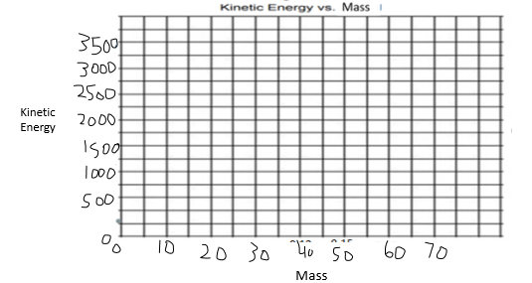

- What is the relationship of mass to kinetic energy? What does a graph of mass vs kinetic energy look like?
- What is the relationship of speed to kinetic energy? What does a graph of speed vs kinetic energy look like?
- Be able to explain the relationship between potential energy and kinetic energy.
- Which two factors affect kinetic energy? Mass and speed.
- A 30 kg ball and a 20 kg ball are rolling across Mr. Doming’s Driveway at the same speed. Which ball has more Kinetic Energy?
- Mr. Doming and Ms. Cloonan have the same mass. They decide to race each other. Mr. Doming ran at 10 m/s and Ms. Cloonan ran at 5 m/s. Which teacher has more kinetic energy?
- Define kinetic energy and provide an example.
- Define Mass and provide an example.
- Define Speed and provide an example.
- Define the Law of Conservation of Energy and provide an example.
Potential Energy:
Be able to answer the following questions:
- What is potential energy?
- What is an example of potential energy?
- Where on a rollercoaster is there the most potential energy and the most kinetic energy?
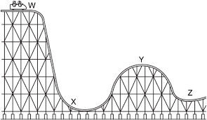
- What are the different types of potential energy (gravitational, chemical, elastic, nuclear, electrostatic, magnetic)?
- Which two factors affect gravitational potential energy?
- Two rocks are hanging at the edge of the same cliff. ROCK A has a mass of 30 kg and ROCK B has a mass of 20 kg. Which rock has more potential energy? Explain why.
- Look at the table below. Based on the information in the table, which ball would have the most potential energy? Explain why.
Ball | Height in the air (m) | Mass (g)
Ball A | 10 m | 50 g
Ball B | 5 m | 50 g
Ball C | 15 m | 50 g
Ball D | 7 m | 50 g

- Look at the picture below. At which point would the skater have roughly 50% potential energy and 50% kinetic energy?
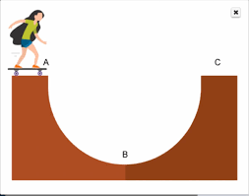
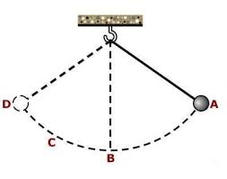
Electric and Magnetic Forces

- Be able to define and identify the following terms: Electric field, electric force, magnetic force, electromagnetic force, attraction, repulsion, electric current, charged object.
- How does distance affect the strength of electric and magnetic forces? Explain.
- What are the ways we can increase the strength of an electromagnet?
- Analyze the data in the table: what is happening to the strength of the electromagnet when the amount of copper wire is increased?

Amount of copper wire (cm) | Staples picked up by electromagnet
100 cm | 5
125 cm | 7
150 cm | 9
200 cm | 13
- Which kind of force is shown by the interaction of these two magnets?

- What will happen if balloon 1 is moved toward balloon 2?
- What will happen to the strength of the electric force if Balloon 1 is moved away from Balloon 2?
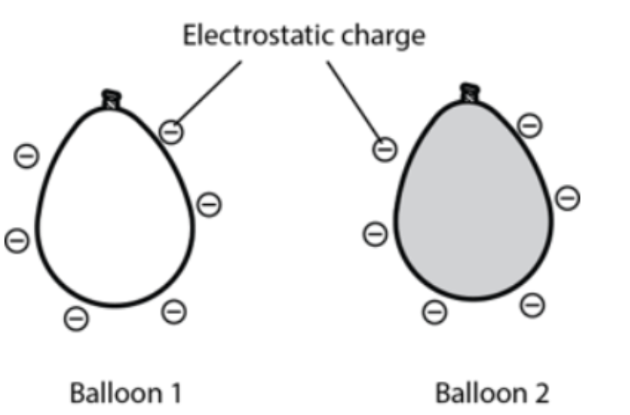
- Can objects interact with each other without touching? Explain and give an example.

