Sixth Grade Math Assignment
Directions: Complete the math problems below on the Microsoft Word document. When you are finished you will submit in Teams.
Perimeter: the total of the outside edges
Area: the total space inside a shape, found by multiplying base x height
Example:
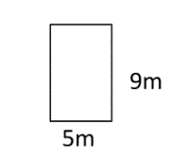
Perimeter | 28 m
Area | 45 square meters

Problems:
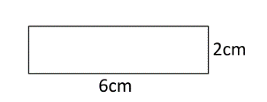
Perimeter | cm
Area | square cm

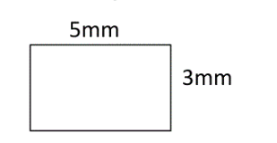
Perimeter | mm
Area | square mm

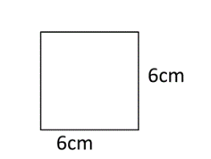
Perimeter | cm
Area | square cm

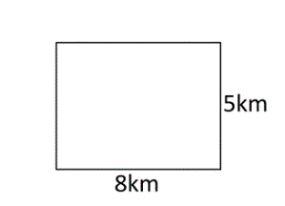
Perimeter | km
Area | square km

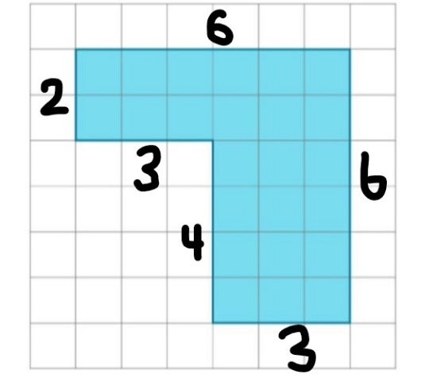
Perimeter | Units
Area | Square Units

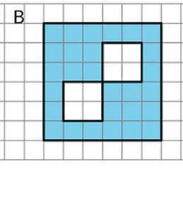
Area | Square units

