Unit 1, Lesson 5: Practice Problems
- Rectangles P, Q, R, and S are scaled copies of one another. For each pair, decide if the scale factor from one to the other is greater than 1, equal to 1, or less than 1.
- 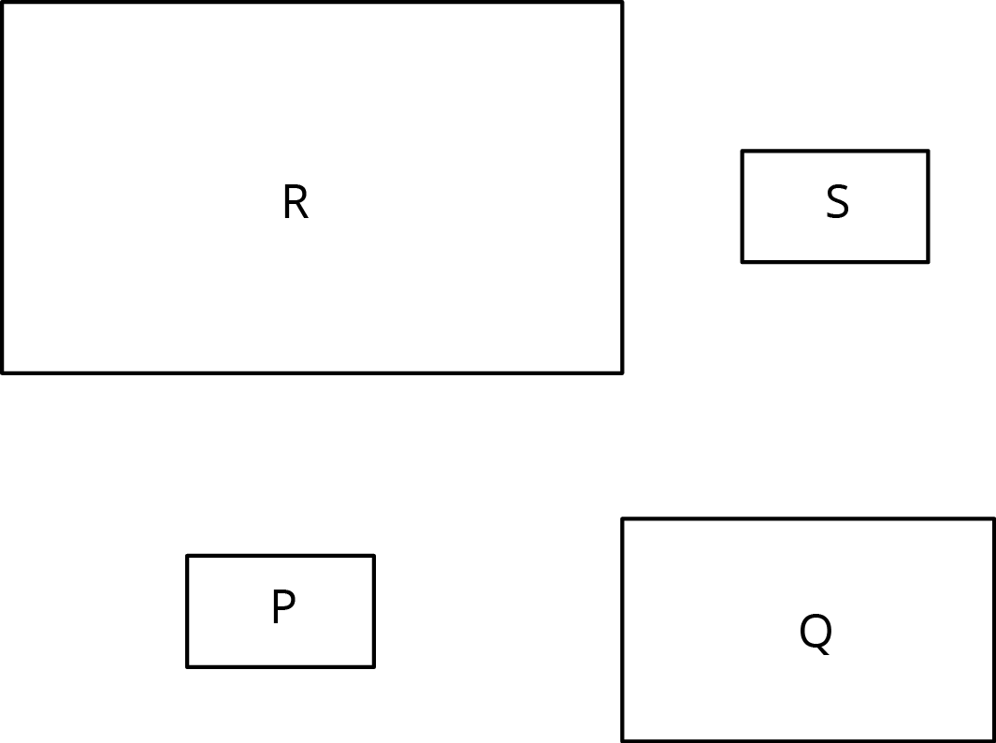
  - from P to Q
  - from P to R
  - from Q to S
  - from Q to R
  - from S to P
  - from R to P
  - from P to S
- Triangle S and Triangle L are scaled copies of one another.
  - What is the scale factor from S to L?
  - What is the scale factor from L to S?
  - Triangle M is also a scaled copy of S. The scale factor from S to M is $\frac{3}{2}$. What is the scale factor from M to S?
- 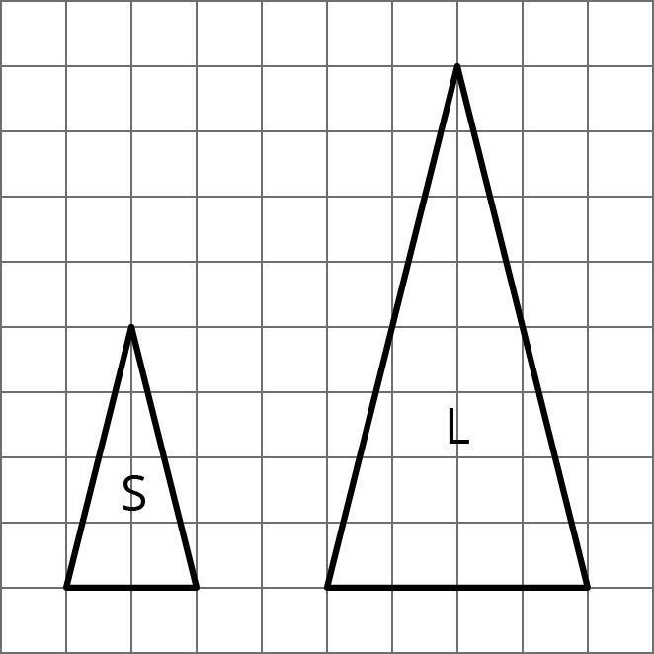
- Are two squares with the same side lengths scaled copies of one another? Explain your reasoning.
- Quadrilateral A has side lengths 2, 3, 5, and 6. Quadrilateral B has side lengths 4, 5, 8, and 10. Could one of the quadrilaterals be a scaled copy of the other? Explain.
- Select all the ratios that are equivalent to the ratio $12:3$. Explain how you know.
  - $6:1$
  - $1:4$
  - $4:1$
  - $24:6$
  - $15:6$
  - $1,​200:300$
  - $112:13$

