Claim-Evidence-Reasoning Organizer

DIRECTIONS: Use the check-off list to the left of each component to verify that you have everything required to create a complete a CLAIM with EVIDENCE and appropriate REASONING. CHECK off each item that you included – failure to do so will result in loss of points.
PROMPT: Use the evidence you have gathered from the simulation to argue the claim that gravitational force is attractive and depends on the masses of the interacting objects.
YOU SHOULD USE THE FOLLOWING VOLCABULARY: Gravity, Mass, Distance, Rotation, Orbit, Attraction/Attractive

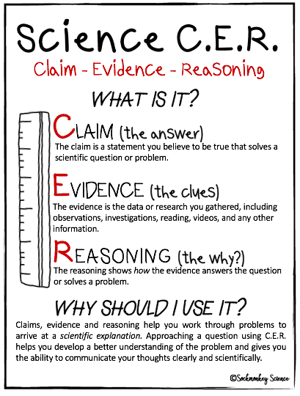

CLAIM: A statement that answers the original question.
Must do ALL …
- complete sentence (capital letter, end-mark, etc.)
- restates question
- answers question (without reasons or data yet)
- includes important vocabulary
EVIDENCE: The data that supports the claim.
- Minimum of three pieces of evidence (gathered from the simulation).
- Must directly support the claim.
- Must cover both mass and distance.
REASONING: A statement or conclusion that answers the original question/problem.

Should do ALL:

- restate the claim as a fact.
- define ALL important vocabulary or concepts
- Address all three (3) pieces of evidence and explain the importance of EACH piece of evidence
- uses words such as: since, because, reason, cause, effect, due to, my research shows, the data shows, this means, for example, etc.
- complete sentences (capital letters, end marks, etc.)

