Name:
Early Hominin Capabilities

Read the section about each hominin and then draw/color/highlight their major capabilities on the image. After marking the picture be sure to explain why you marked the things you did, be sure to follow the prompt for the required words to be included in your answer.

Handy Man
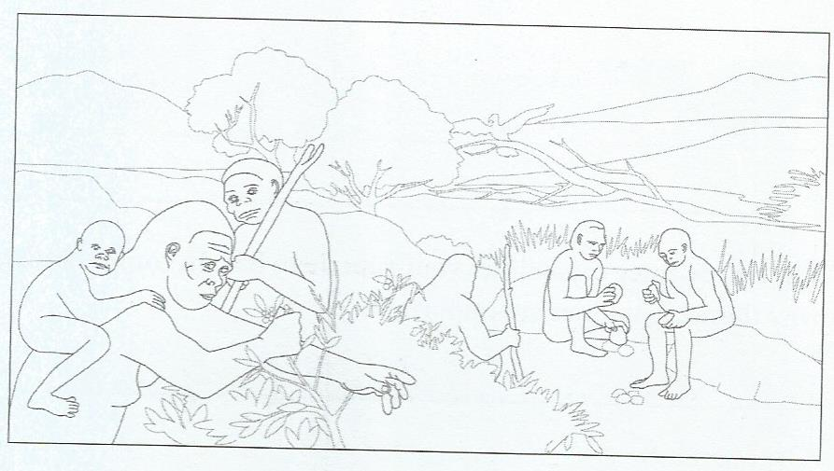 | Explain why each capability you labeled was important for survival. Include the following words in your explanation: groups, tools.

Upright Man
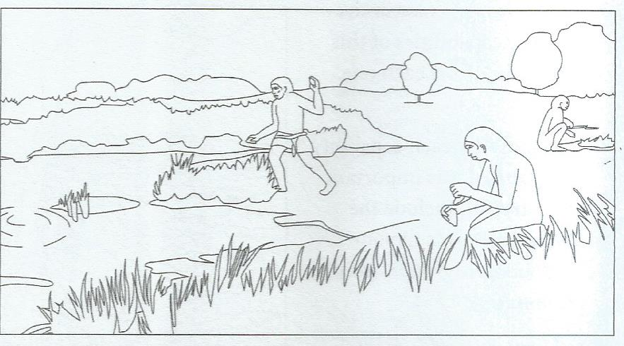
Explain why each capability you labeled was important for survival. Include the following words in your explanation: strong bones, fire, shelter

Neanderthal Man
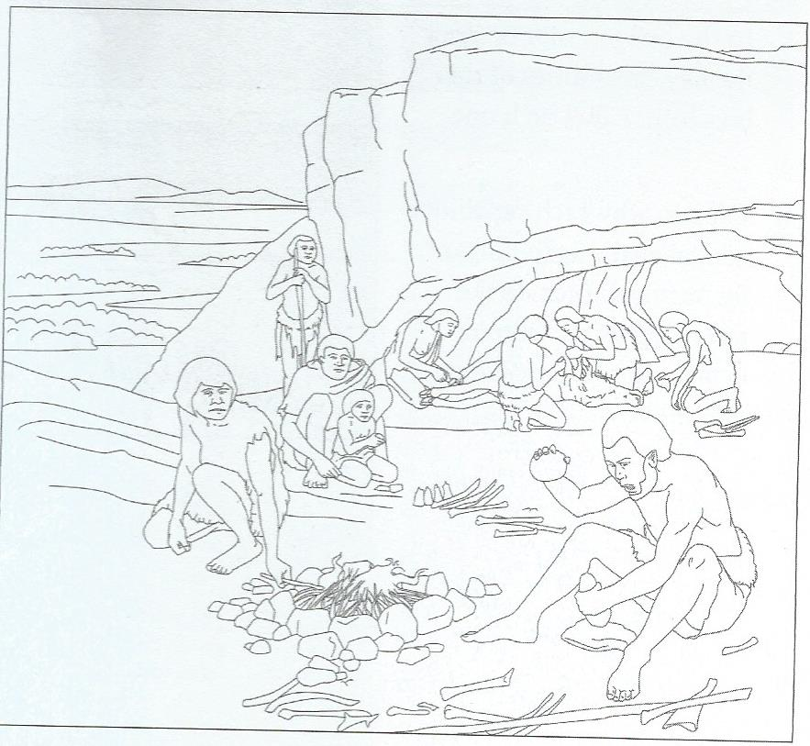
Explain why each capability you labeled was important for survival. Include the following words in your explanation: groups, spears, community

Wise Man
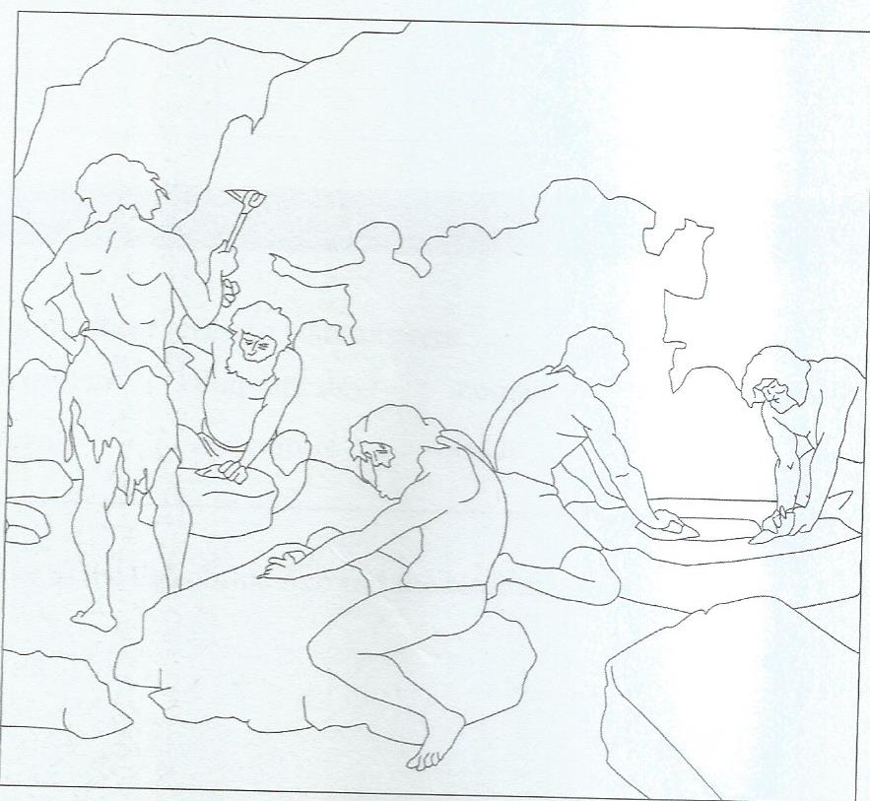
Explain why each capability you labeled was important for survival. Include the following words in your explanation: tools, clothing, weapons, artwork.

