Area of a Triangle
A = ½ base x height
- Multiply base x height
- Take that number and multiply by ½ (or .5)
- That is your area of a triangle
Example
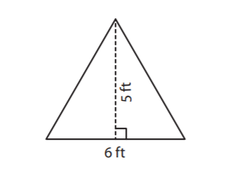
Base = 6 ft
Height = 5ft
- Base x height = 6 x 5 = 30
- 30 x .5 = 15
- Area = 15 square ft
Problems
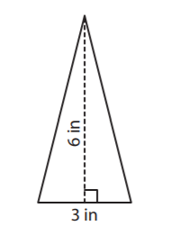
Area =
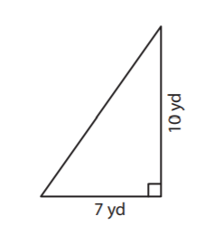
Area =
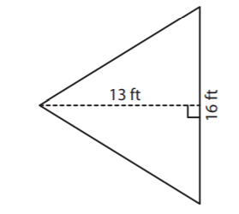
Area =
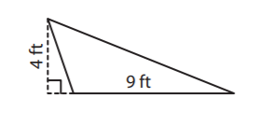
Area =
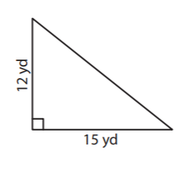
Area =

